Coursework Report: Programming and Program Design (7WCM2009-0911-2026)

Ashutosh Dilip’s contribution: 25010461

Overview
The ‘ppd_cli_tool’ is an interactive Kotlin command line utility that performs 3 different mathematical calculations based on the user’s input. The functions are to find the Harmonic Sum, Greatest Common Divisor (GCD), and a sum of the Fibonacci series up to a given number.
The complete code can be found on our public GitHub repository. The code files are organized in the ‘src’ folder and the documentation about the various functions can be found in the ‘Documentation’ folder. The README explains how to build and run the code using Gradle and JDK 25. @Rosa can you copy over the documentation about the functions in the final report?

Fibonacci Function

Description
The Fibonacci sequence is a series of numbers that begin with 0 and 1, and each subsequent number is the sum of the two numbers before it.
It is defined as follows:
$$F_{n} = F_{n-1} + F_{n-2}$$
given
F₀ = 0
F₁ = 1
There is also a shortcut that makes it computationally easier to find the Fibonacci sum up to index n:
$$\sum_{i=0}^{n}{F_{i} = F_{n+2} - 1}$$

Function Logic
The function to compute the Fibonacci sum up to index n works as follows:
- Validate that n is a valid input (see the next section).
- Compute the (n+2)th term of the Fibonacci sequence.
- Subtract 1 from it and return the answer.

Input Validation
The following validations must be performed on the input variable n:
- n must be a valid number. readln() always returns a string, which must be correctly converted to a number.
- n must be a natural number in the range n ∈ {1, 2, 3, …, ∞}.
- n must not be so large that it causes integer overflow in the sum variable, or takes a very long time to compute. A suitable limit must be decided. For now, the number 100 has been selected. Fibonacci sum up to the index 100 is 927372692193078999175.

Function
The function could be implemented as follows:
package commands.fibonacci
import java.math.BigInteger
// The maximum value allowed for the input n
val MAX_N: Int = 100
/**
* @param userInput The input string from the user containing the number n
* @return The Fibonacci sum until the number n
* @throws IllegalArgumentException When input validation fails
*/
fun calculateFibonacciSum(userInput: String) : String {
// Convert to integer
val n: Int? = userInput.toIntOrNull()
// Validate inputs
when {
n === null -> throw IllegalArgumentException("The input $userInput is not a valid integer.")
n < 1 -> throw IllegalArgumentException("The input $userInput is less than 1.")
n > MAX_N -> throw IllegalArgumentException("The input $userInput is greater than $MAX_N.")
}
// We compute up to index n + 2
val targetIndex = n + 2
// Use previous and current number to track the series
var previous = 0.toBigInteger()
var current = 1.toBigInteger()
// Compute the (n+2)th Fibonacci number iteratively
for (i in 2..targetIndex) {
val next = previous + current
previous = current
current = next
}
// Return F(n+2) - 1
return (current - 1.toBigInteger()).toString()
}

Main Function

Description
An entry-point function is required for user interaction. This interactive function must take inputs from the user, validate them, and output the appropriate results. It should also have additional features such as displaying a help message and cleanly exiting the program.

Function Logic
The logic of the function can be seen in the flow chart below.
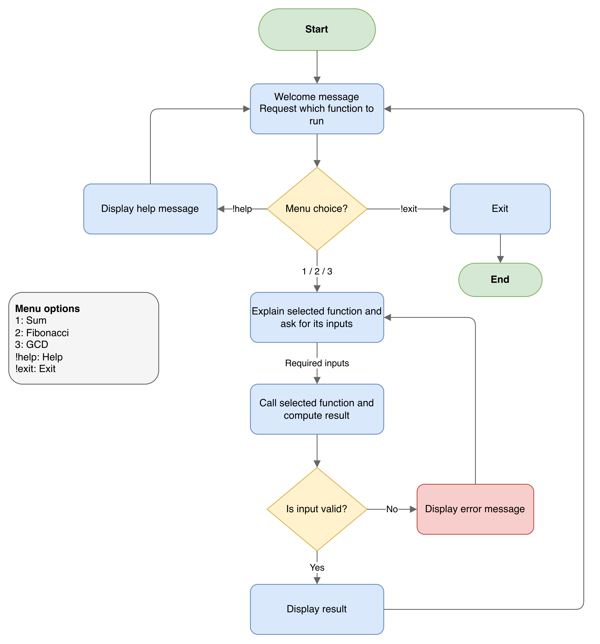

Function
The function is implemented as follows, along with a helper function ‘prompt’ to get user inputs.
package ppdCliTool
import commands.fibonacci.calculateFibonacciSum
import commands.gcd.calculateGcd
import commands.help.help
import commands.sum.calculateHarmonic
import kotlin.system.exitProcess
/**
* Entry point of the ppd_cli_tool.
*
* Shows the welcome message, then loops over the main menu until the user
* types `!exit` or input is closed with Ctrl + D.
*/
fun main(): Unit {
println("Welcome to the group coursework application for the module Programming and Program Design.")
println("Created by:\nAshutosh Dilip: 25010461\nGeoffrey Lee: 12345678\nRosa Erdogan: 13245678")
while (true) {
println("\nMenu\n-------")
println("1. Series Sum\n2. Greatest Common Divisor\n3. Fibonacci Series Sum")
println("!help - Display help\n!exit - Exit program")
when (prompt("Select an option: ") ?: return) {
"1" -> {
while (true) {
val n = prompt("Enter an integer: ") ?: return
try {
println("\nResult: ${calculateHarmonic(n)}")
break
} catch (exc: Exception) {
println("\nError: ${exc.message}")
}
}
}
"2" -> {
while (true) {
val a = prompt("Enter the first integer: ") ?: return
val b = prompt("Enter the second integer: ") ?: return
try {
println("\nResult: ${calculateGcd(a, b)}")
break
} catch (exc: Exception) {
println("\nError: ${exc.message}")
}
}
}
"3" -> {
while (true) {
val n = prompt("Enter an integer: ") ?: return
try {
println("\nResult: ${calculateFibonacciSum(n)}")
break
} catch (exc: Exception) {
println("\nError: ${exc.message}")
}
}
}
"!help" -> println("\n${help()}")
"!exit" -> {
println("\nThank you for using the application.")
exitProcess(0)
}
else -> println("\nInvalid option. Enter 1, 2, 3, !help or !exit.")
}
}
}
/**
* Prints [message] and reads one line of input.
*
* Trims the line and re-prompts while it is empty.
*
* @param message The message to show before reading input.
* @return The trimmed input, or `null` if input is closed (Ctrl + D).
*/
fun prompt(message: String): String? {
while (true) {
print("\n$message")
val input = readlnOrNull()?.trim() ?: return null
if (input.isNotEmpty()) return input
println("\nYour input was empty, please try again...")
}
}

Build
The tool is built using Gradle with JDK 25 and Kotlin 2.4.0. The repository includes the gradle build script, which can be executed directly using JDK 25. A Java ‘.class’ file is then created within the user’s build folder.

Readme
A README file has been placed in the root folder with complete instructions about how to set up and get the tool running. All necessary dependencies have been mentioned.

Screenshots
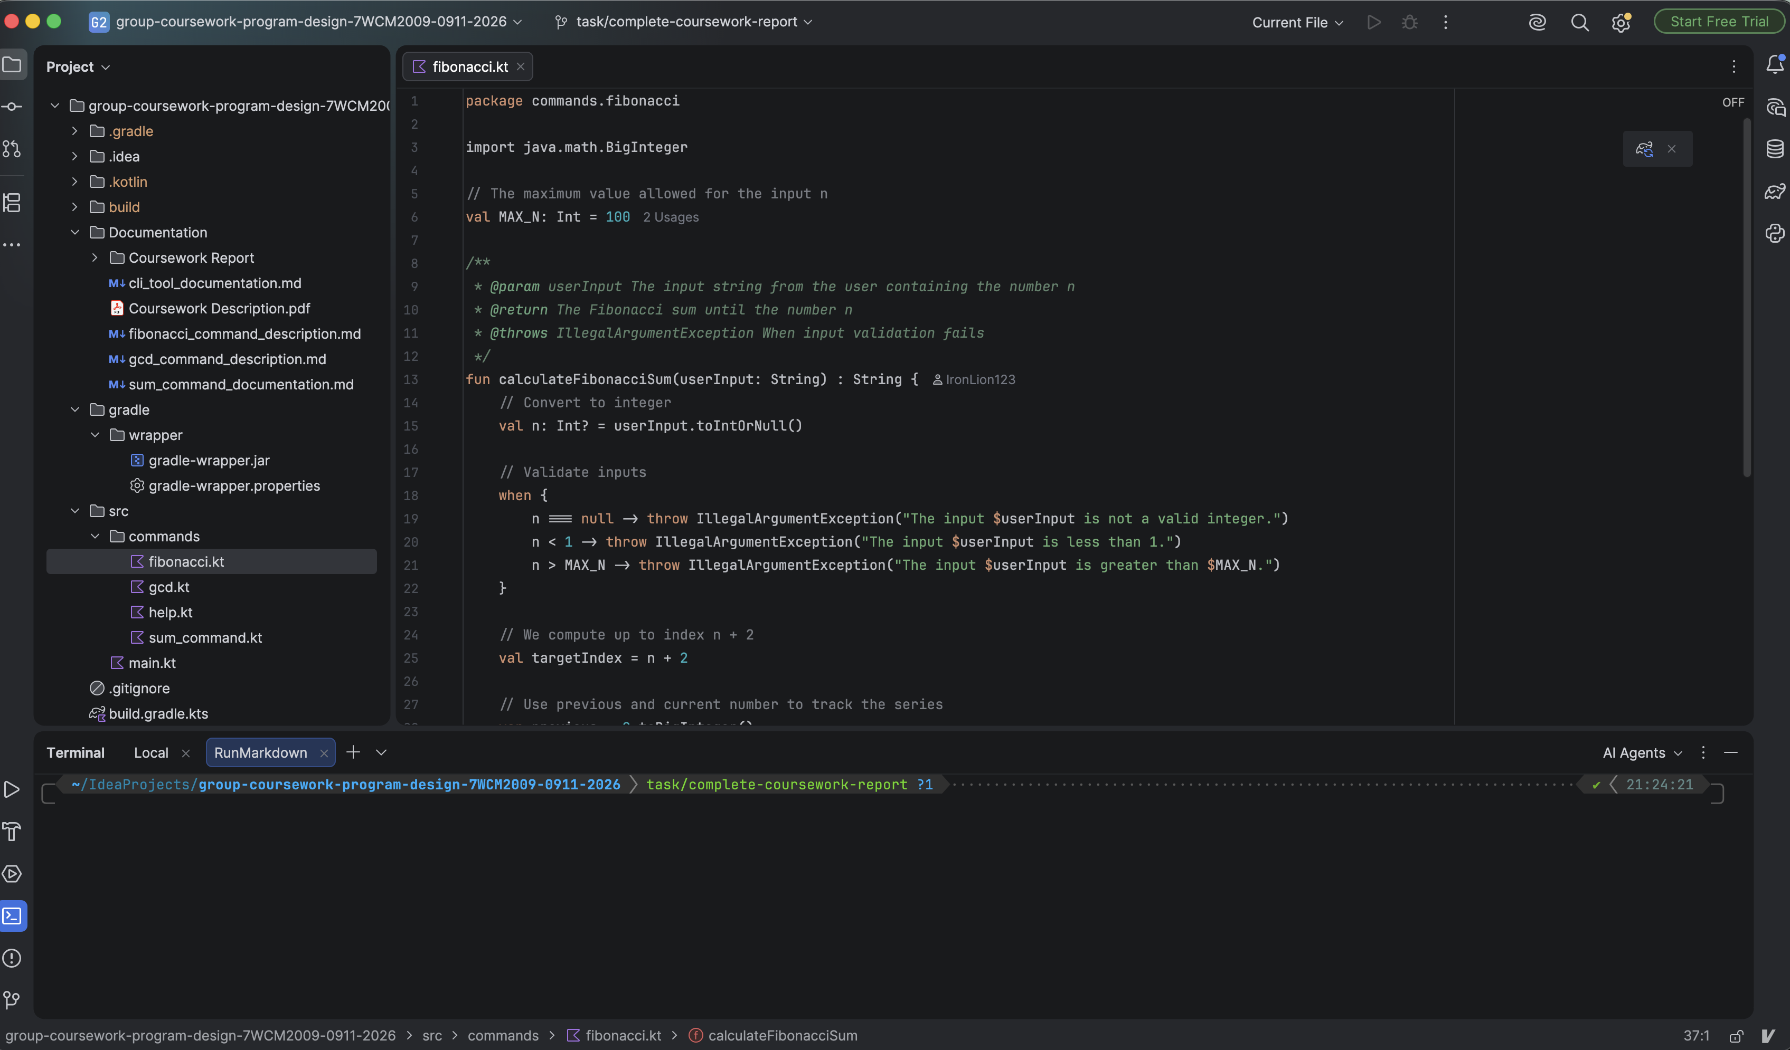
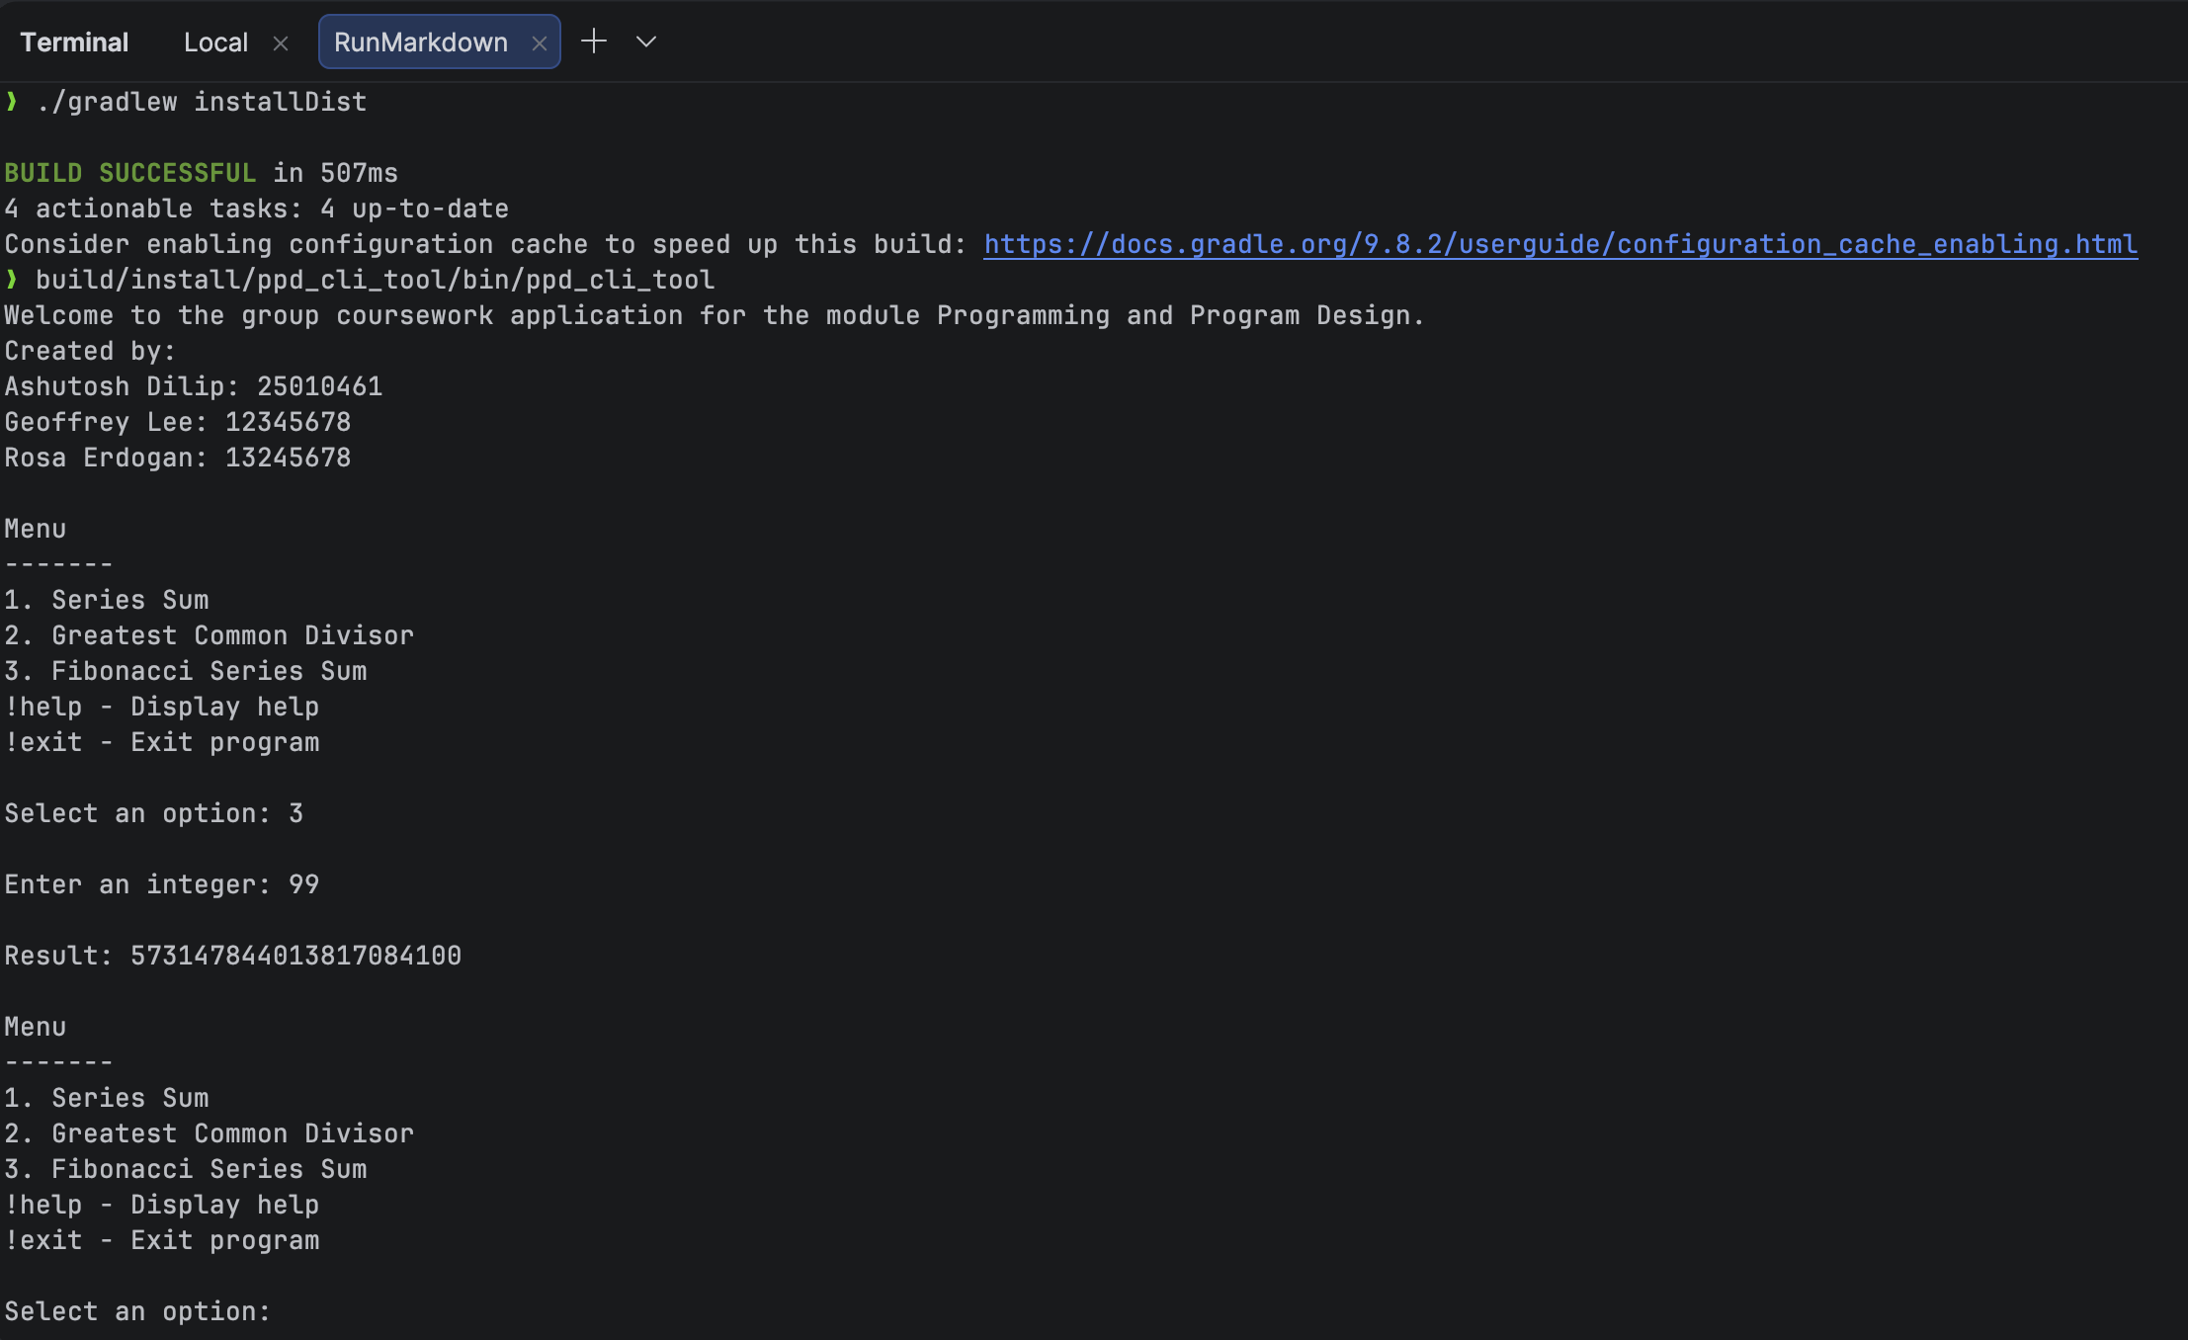
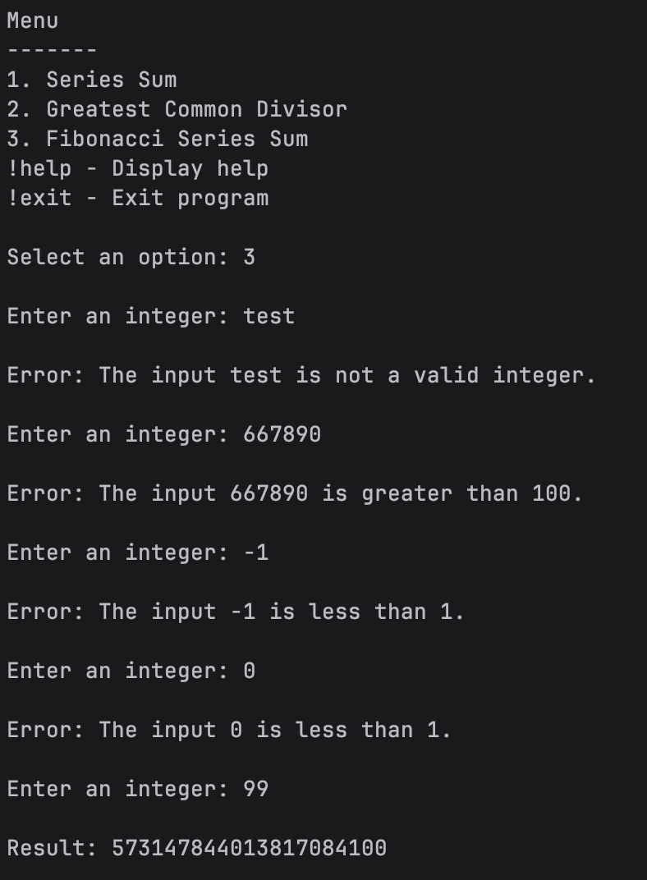

Reflection as a group
Several changes were made to the code after discussions with the other group members. The logic of the main function was created together on a call. Decisions regarding the max values for the input and the other input validations were also taken together as a team.

